**PROGRAM 9**

**MOVIE DATABASE**

CREATE DATABASE MOVIE;

USE MOVIE;

CREATE TABLE ACTOR (

ACT_ID INT,

ACT_NAME VARCHAR (20),

ACT_GENDER CHAR (1),

PRIMARY KEY (ACT_ID));

DESC ACTOR;

CREATE TABLE DIRECTOR (

DIR_ID INT,

DIR_NAME VARCHAR (20),

DIR_PHONE REAL,

PRIMARY KEY (DIR_ID));

DESC DIRECTOR;

CREATE TABLE MOVIES (

MOV_ID INT,

MOV_TITLE VARCHAR (25),

MOV_YEAR INT,

MOV_LANG VARCHAR (12),

DIR_ID INT,

PRIMARY KEY (MOV_ID),

FOREIGN KEY (DIR_ID) REFERENCES DIRECTOR (DIR_ID));

DESC MOVIES;

CREATE TABLE MOVIE_CAST (

ACT_ID INT,

MOV_ID INT,

ROLE VARCHAR (10),

PRIMARY KEY (ACT_ID, MOV_ID),

FOREIGN KEY (ACT_ID) REFERENCES ACTOR (ACT_ID),

FOREIGN KEY (MOV_ID) REFERENCES MOVIES (MOV_ID));

DESC MOVIE_CAST;

CREATE TABLE RATING (

MOV_ID INT,

REV_STARS VARCHAR (25),

PRIMARY KEY (MOV_ID),

FOREIGN KEY (MOV_ID) REFERENCES MOVIES (MOV_ID));

DESC RATING;

INSERT INTO ACTOR VALUES (301,'ANTHONY PERKINS','M');

INSERT INTO ACTOR VALUES (302,'SAOIRSE RONAN','F');

INSERT INTO ACTOR VALUES (303,'UMA THURMAN','F');

INSERT INTO ACTOR VALUES (304,'LEONARDO DICAPRIO','M');

INSERT INTO ACTOR VALUES (305,'VIDYA BALAN','F');

INSERT INTO ACTOR VALUES (306,'NAWAZUDDIN SIDDIQUI','M');

SELECT * FROM ACTOR;

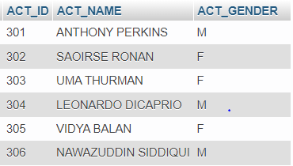

INSERT INTO DIRECTOR VALUES (60,'GRETA GERWIG', 8751611001);

INSERT INTO DIRECTOR VALUES (61,'HITCHCOCK', 7766138911);

INSERT INTO DIRECTOR VALUES (62,'STEVEN SPIELBERG', 9986776531);

INSERT INTO DIRECTOR VALUES (63,'QUENTIN TARANTINO', 8989776530);

INSERT INTO DIRECTOR VALUES (64,'SUJOY GHOSH', 9783335281);

COMMIT;

SELECT * FROM DIRECTOR;

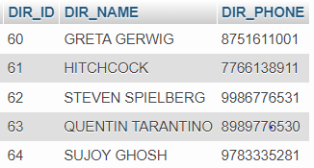

INSERT INTO MOVIES VALUES (1001,'LITTLE WOMEN',2019,'ENGLISH',60);

INSERT INTO MOVIES VALUES (1002,'KAHAANI',2012,'HINDI',64);

INSERT INTO MOVIES VALUES (1003,'KILL BILL : VOL.1',2003,'ENGLISH',63);

INSERT INTO MOVIES VALUES (1004,'PSYCHO',1960,'ENGLISH',61);

INSERT INTO MOVIES VALUES (1005,'CATCH ME IF YOU CAN',2002,'ENGLISH',62);

INSERT INTO MOVIES VALUES (1006,'ONCE UPON A TIME IN HOLLYWOOD',2019,'ENGLISH',63);

INSERT INTO MOVIES VALUES (1007,'KAHAANI 2: DURGA RANI SINGH',2016,'HINDI',64);

COMMIT;

SELECT * FROM MOVIES;

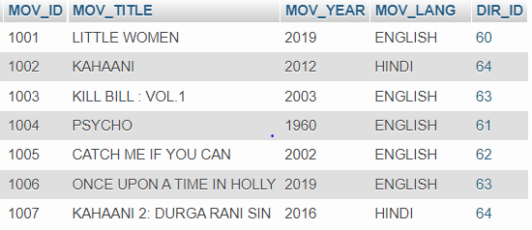

INSERT INTO MOVIE_CAST VALUES (301,1004,'HERO');

INSERT INTO MOVIE_CAST VALUES (302,1001,'HEROINE');

INSERT INTO MOVIE_CAST VALUES (303,1003,'HEROINE');

INSERT INTO MOVIE_CAST VALUES (304,1005,'HERO');

INSERT INTO MOVIE_CAST VALUES (305,1002,'HEROINE');

INSERT INTO MOVIE_CAST VALUES (306,1002,'HERO');

INSERT INTO MOVIE_CAST VALUES (304,1006,'HERO');

INSERT INTO MOVIE_CAST VALUES (305,1007,'HEROINE');

COMMIT;

SELECT * FROM MOVIE_CAST;

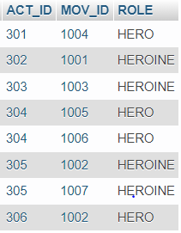

INSERT INTO RATING VALUES (1001, 4);

INSERT INTO RATING VALUES (1002, 4);

INSERT INTO RATING VALUES (1003, 3);

INSERT INTO RATING VALUES (1004, 5);

INSERT INTO RATING VALUES (1005, 4);

INSERT INTO RATING VALUES (1006, 4);

INSERT INTO RATING VALUES (1007, 3);

COMMIT;

SELECT * FROM RATING;

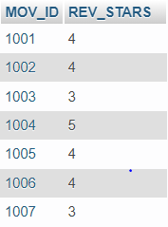

**QUERIES:**

**1)List the titles of all movies directed by 'SUJOY GHOSH'.**

SELECT MOV_TITLE

FROM MOVIES

WHERE DIR_ID IN (SELECT DIR_ID

FROM DIRECTOR

WHERE DIR_NAME = 'SUJOY GHOSH');

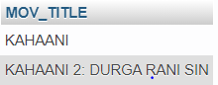

**2)Find the movie names where one or more actors acted in two or more movies.**

SELECT MOV_TITLE

FROM MOVIES M, MOVIE_CAST MV

WHERE M.MOV_ID=MV.MOV_ID AND ACT_ID IN (SELECT ACT_ID

FROM MOVIE_CAST GROUP BY ACT_ID

HAVING COUNT(ACT_ID)>=1)

GROUP BY MOV_TITLE

HAVING COUNT(*)>1;



**3) List all actors who acted in a movie before 2000 and also in a movie after 2015 (use JOIN operation).**

SELECT ACT_NAME, MOV_TITLE, MOV_YEAR

FROM ACTOR A

JOIN MOVIE_CAST C

ON A.ACT_ID=C.ACT_ID

JOIN MOVIES M

ON C.MOV_ID=M.MOV_ID

WHERE M.MOV_YEAR NOT BETWEEN 2000 AND 2015;

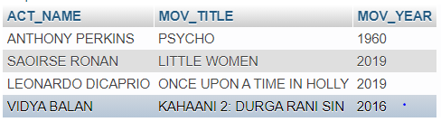

**4)Find the title of movies and number of stars for each movie that has at least one rating and find the highest number of stars that movie received. Sort the result by movie title.**

SELECT MOV_TITLE, MAX(REV_STARS)

FROM MOVIES

INNER JOIN RATING USING (MOV_ID)

GROUP BY MOV_TITLE

HAVING MAX(REV_STARS)>0

ORDER BY MOV_TITLE;

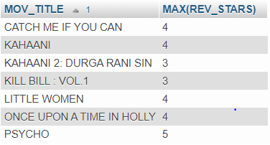

**5)Update rating of all movies directed by ‘Steven Spielberg’ to 5**

SET SQL_SAFE_UPDATES = 0;

UPDATE RATING

SET REV_STARS=5

WHERE MOV_ID IN (SELECT MOV_ID FROM MOVIES

WHERE DIR_ID IN (SELECT DIR_ID FROM DIRECTOR

WHERE DIR_NAME = 'STEVEN SPIELBERG'));

SELECT * FROM RATING;

SET SQL_SAFE_UPDATES = 1;

